IMPLEMENTATION OF PROJECT BASED LEARNING (PJBL) IN CRITICAL STUDENT’S CHARACTER DEVELOPMENT ORIENTED Suprapto¹, Maryam Sulaeman²*
^{1,2}Universitas Islam Jakarta, Indonesia

*Corresponding author email: maryamsulaeman@yahoo.co.id

Article Info | Abstract
Received:  Revise:  Accepted: | The Distance Learning Process is a solution to the Covid-19 pandemic situation which is considered more effective and efficient, but there are various kinds of problems, not only educators and students, but also parents. The problems faced are the difficulty of supervising students who lack honesty and discipline in doing and collecting assignments, supervising students who do not focus on learning, difficult to adapt which make character development less effective. The specific purpose of the research is to produce a Project Based Learning model that can improve students' ability to solve problems, and it is hoped that students will be more active, independent and responsible. The method used is Action Research to produce certain products, and test the effectiveness of the product through various stages and validation with the following steps: 1) planning, 2) acting, 3) monitoring, and 4) reflecting. The results of the study found that scores were still very lacking in the first and second cycles in fostering a critical attitude to students, but in the third cycle significant improvements were found. This is evidenced in the reflection of most students. Future research requires a model for applying critical thinking in higher education  Keyword: Project Based Learning (PBL), Character Building, critical thinking
Publisher:
Universitas Mohammad Husni Thamrin, Jl. Raya Pondok Gede No.23-25 East Jakarta 13550, Website: thamrin.ac.id

Copyright © 202x
How to cite:

INTRODUCTION
Project Based Learning (PjBL) as a learning model that is centered on learners to conduct an in-depth investigation of a topic and use projects/activities as media. Learners do exploration, assessment, interpretation, to produce various forms of learning outcomes. Students take a research-based approach to problems through meaningful, real, and relevant questions. The Project Based Learning (PjBL) model can increase the accuracy of students in learning, (Efrimal, Kurnia, & Wasidi, 2017) more interestingly, it can be applied at all levels of education ranging from SD/MI (Elementary School), SMP/MTs (Junior High School), SMA/MA (Senior High School), even in Higher Education (PT) . This model also applies to all disciplines or subjects from all levels of education that have been proven to be able to deliver students to have extraordinary abilities in the cognitive, affective and psychomotor domains through scientific approach. (Efrimal et al., 2017)
Since the Covid-19 pandemic that hit the world, all the system of human life has changed in all areas, including the world of education, Distance Learning (PJJ) has become the main choice in the learning process by utilizing technology as a learning medium. However, behind learning that is considered more effective and efficient, there are various kinds of problems faced, not only by educators and students, but also by parents. During the learning process, several problems emerged, including: Limited infrastructure facilities such as laptops or cellphones owned by parents and students, lack of mastery of science and technology (Science and Technology), difficulty in accessing the internet due to unstable networks, high quota fees, and constraints of time (Marlina & Cahyono, 2022).
Thus, the learning time is reduced so that the teacher cannot fulfill the load of his teaching hours, (Dian Primasari & Zulela, 2021) the difficulty of monitoring the attitudes of students such as honesty, discipline in doing and collecting assignments, and characters that have not been touched optimally overall, the difficulty Supervise students who do not focus on learning. It is difficult for students to adapt who have problems absorbing subject matter, and who feel bored, stressed and complain about the many assignments from lecturers, and have difficulty communicating with parents as companions and mentors when studying at home, all of which can lead to character building and learning become less effective.
The specific purpose of this research is to analyze the application of the Project Based Learning (PjBL) model in the post-covid-19 pandemic as an effort to build the character of students. This Project Based Learning (PjBL) learning model is important because it is considered appropriate to make learning activities effective as an effort to build character.This learning model allows learning to run effectively without having to meet face-to-face with students, take a research-based approach in problems and questions that are weighty, real, and relevant (Setiono, Yuliantini, & Dadi, 2020). It’s able to overcome learning saturation and supervise the honesty of students by being given the task of solving problems, therefore the Project Based Learning learning model is effective and feasible to be applied as a strengthening of student character.
A.Project Based Learning (PjBL)
The Project Based Learning (PjBL) model is a learning strategy that aims to provide opportunities for students to carry out group activities, which are reflected in real life. In addition there are some positive impacts in this approach: 1) Project Based Learning can improve students' critical thinking skills and 2) have skills that make it easier for students, (Komara, 2018) can increase accuracy in learning to be effective and increase student creation, and can improve student learning outcomes through online learning during the Covid-19 pandemic (Hayati, Utaya, & Astina, 2016)
Along with the above, the 21st century learning model is directed to: 1) encourage students to find out from various sources, 2) be able to formulate problems, and solve problems. 3) train analytical thinking, 4) emphasize the importance of cooperation and collaboration in solving problems (Ramadan, 2020).
Previous researchers who have reviewed the Project Based Learning (PjBL) model reported mixed results. The findings explain that the results of students using the Project Based Learning (PjBL) model are better than students learning to use the STAD type cooperative learning model (Wulandari, Suardana, & Devi, 2019). The application of Project Based Learning (PjBL) in learning is oriented towards the development of critical students' character, as evidenced by the increase in character values in the friendly, critical, creative, curious, conscientious, and environmentally friendly aspects (Setiono et al., 2020). The Project Based Learning (PjBL) method is very important in improving students' critical, creative and student-centered thinking skills. The advantages of this method can reveal facts, so that its application is said to be effective (Utomo, Abidin, & Rigiyanti, 2020).
Several studies above make Project Based Learning (PjBL) a learning model that involves students in problem solving activities and provides opportunities to work autonomously, constructing their own learning, no research has been found that directly integrates Project Based Learning (PjBL) in oriented learning on the development of critical student character. Thus the implementation of Project Based Learning (PjBL) which will be carried out as part of building character by providing flexibility, involving students in activities, providing opportunities to work autonomously, and constructing their own learning which refers to processing values within the scope of thoughts, feelings, physical or physical, and processing of the heart (Purwadhi, 2019). This research is an effort to improve the quality of learning through the application of the Project Based Learning (PjBL) model in learning oriented to the development of critical character of students. This activity is effective, it can meet the demands of students in the 2nd century where students need communication, group work, creativity, skills, and problem solving. This method is able to overcome learning saturation and motivate students to learn, so the students become active, creative, and innovative (Puji Rahmawati, 2015).
The Project Based Learning (PjBL) model can improve students' communication skills. directly or indirectly so as to produce the same understanding in the classroom, such as listening, studying, interpreting, evaluating etc. PjBL is one of the innovative learning models using projects as learning media (Fauziah, Taufiqulloh, & Sudibyo, 2017).
- Building Critical Character
Along with character building which emphasizes problem-based learning, thinking skills, cooperative, contextual, and affective. Therefore, character building needs to be built though thinking, feeling, careful, and sports. Moreover a very urgent in the strengthening of character building are; tolerance, love of peace, honesty and responsibility, dealing with various cases such as corruption, injustice, etc (Purwadhi, 2019). In other words, student character building and critical thinking skills are important in the learning process to achieve the planned learning objectives (Ratu, Sari, Mukti, & Erfan, 2021). Meanwhile, a research result shows that the active, creative, motivational, and fun learning model is not yet fully maximized in building character, due to the limited ability of teachers, especially innovative learning strategies (Melinda & Zainil, 2020).
Nowadays, the condition of Indonesia's young generation is in a position that is quite disturbing, moral degradation indicates that the younger generation no longer has character, therefore character education is needed (Juliardi, 2015). Building a critical students’ character in this digital era is very important. If you don't have the ability to think critically, it's very easy to fall into things that weaken the nation's character (Pertiwi, Septian, Ashifa, & Prihantini, 2021). A nation is recognized for its existence based on its character. A nation that has a strong character shows an independent nation. Therefore, critical character development needs seriously attention towards religious, democratic, disciplined and responsible character, critical thinking, and caring for others. (Aulia & Dewi, 2021), the dimensions mentioned above can be developed into materials that can help students to be more critical in choosing information (Naufal, 2021).

METHOD
This research uses Action Research (Sugiyono, 2019). This method was developed as one of the practical, integrative and applicable research methods that is carried out in overcoming real problems that develop and are relevant to the activities of the tri dharma of Higher Education where the application of Project Based Learning (PjBL) in learning is oriented towards building the character of students who think critically. carried out within a period of 1 year of research through a learning system that uses projects/activities as media as shown below. In general, the steps of Action Research research are briefly the stages in this research consisting of diagnosis, planning of action (planning), implementation of action (acting), observation (monitoring), and reflection/evaluation (reflecting) as presented in the following figure. The whole cycle is carried out based on the context and objectives of the action research carried out. Here are the steps.
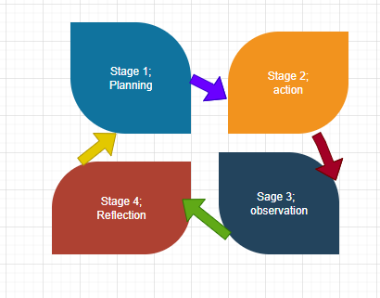
Figure 1. Action Research
From the picture above, it can be explained that these steps are a unity, interrelated, and cannot be separated, and this step becomes a cycle. This means, the cycle of the four actions can be repeated. The cycle can stop when the researcher is satisfied with the results he has achieved as determined before the research is carried out. The Action Research method can be used as a reference source in the context of developing learning models. This development process can help teachers to better understand the nature of action empirically. This is in order to make improvements and improve the services of the teacher's actions in dealing with the learning process. The goal can be achieved by doing reflection to diagnose the condition, then systematically trying various alternative learning models that are believed theoretically and practically that solve learning problems. In other words, the teacher do some plans, implements, evaluates, and reflects.
There are several steps in data collection, including;
Step 1, Planning; In this step, small groups are divided into classes. The directions are given regarding current titles or issues in team projects that they must present in the class.
Step 2, Implementation: In this step students are given the opportunity in groups to express things related to the title in the presentation
Step 3, Observation: In this step as a facilitator the lecturer gives an assessment based on the 2 rubrics that have been prepared,

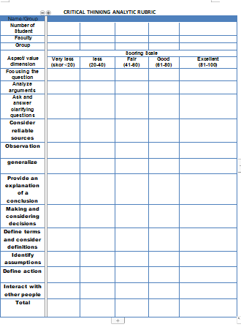
Source; Researcher
Figure 2. Critical thinking analytic rubric

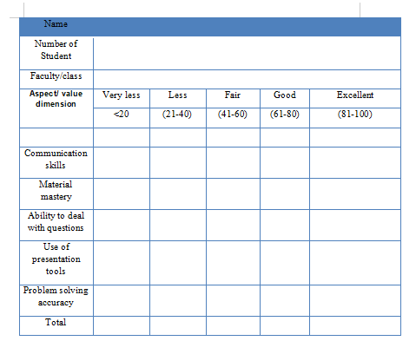
Source; Researcher
Figure 3. Perception Scale Rubric for Oral Presentation Assessment
Step 4, Reflection; In this step, evaluate and determine which ones should be improved again based on the rubric assessment above.

RESULTS AND DISCUSSION

RESULTS
Cycle 1, from the observation of 148 responses consisting of 52% male, and 48% female. The results found that there were still deficiencies in the aspects / dimensions assessed in cycle 1 as shown below in the image below.

Source; Researcher
Figure 4. Critical Thinking Analytic Rubric

Source; Researcher
Figure 5. Scale rubric for oral presntation

DISCUSSION
The research resulted in 3 cycles where the results of the first and second cycles were still low, while in the third cycle there was a significant change in the critical thinking results of students at the Islamic University of Jakarta, Faculty of Islamic Education, as shown below.

Source ; Researcher
Figur 6. Cycle 1-3
There are changes in students' thinking by following several stages including;
1st stage : Giving assignments through group projects;
2nd stage : Build effective communication by habituation, such as; listening, studying, interpreting, and evaluating a discussion;
3rd stage : Observations made by the facilitator;
4th stage : Reflection, in reflection, instruments are given on matters relating to critical thinking as shown below:

- Focusing the question
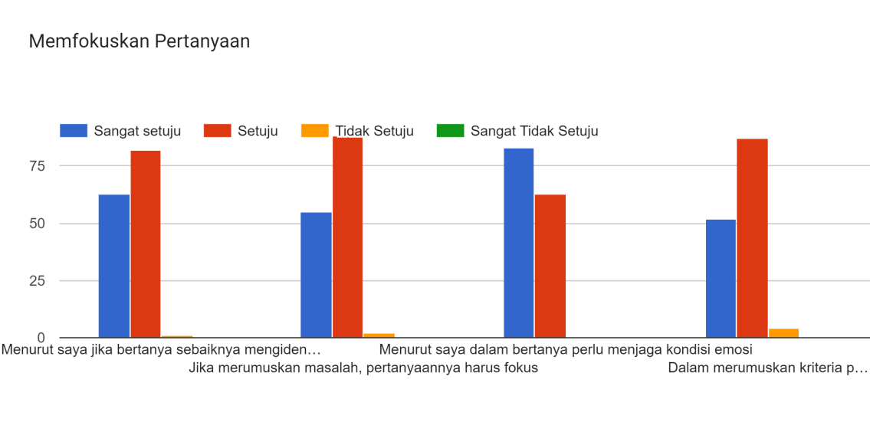
Source ; Researcher
Gambar 7. Focusing the question
Based on the picture above, it was found that as many as 88% of students stated "in formulating the problem the question must focus" and the second largest value was 87% in the item "in formulating the criteria for the question it is necessary to determine the possible answer"
- Analyze Arguments
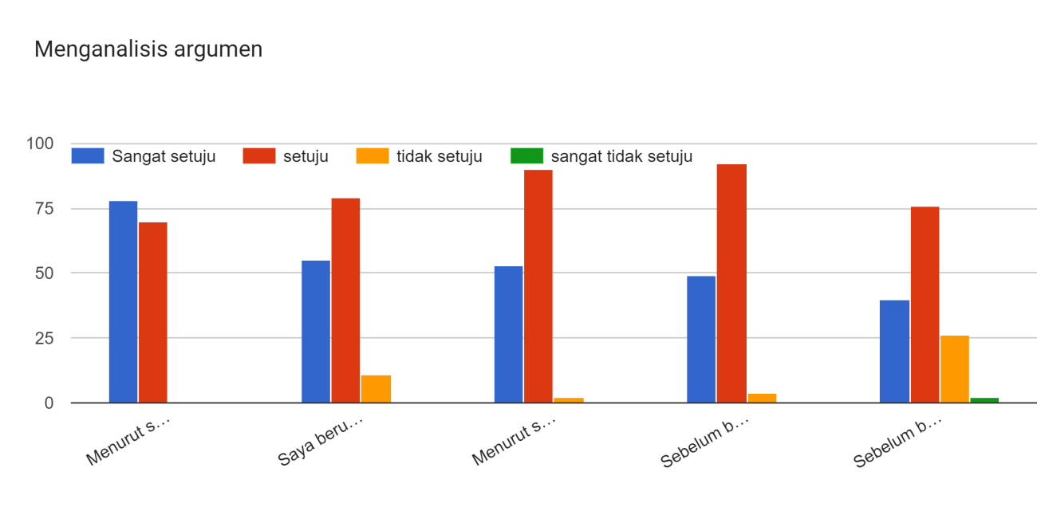
Source ; Researcher
Figure 8. Analyze Arguments

Based on the picture above, it was found that 92% of students stated that before asking students they considered it necessary to identify the reasons to be presented. While in identifying the relevance of the question to find the structure of an argument by 90%.

- Ask and answer clarifying questions
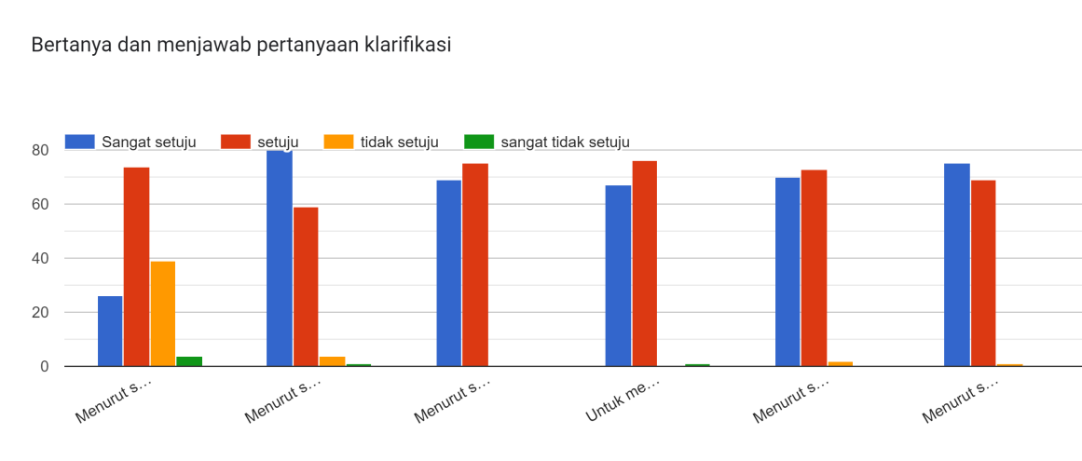
Source ; Researcher
Figure 9. Ask and answer clarifying questions
In the picture above, it is found that the largest value is 80% with the items are "It takes an increase in student character at this time", as much as 78% the need for character application towards a rational and intelligent society" and finally 75% stated "the main learning objectives should be oriented towards character building.

- Consider reliable sources

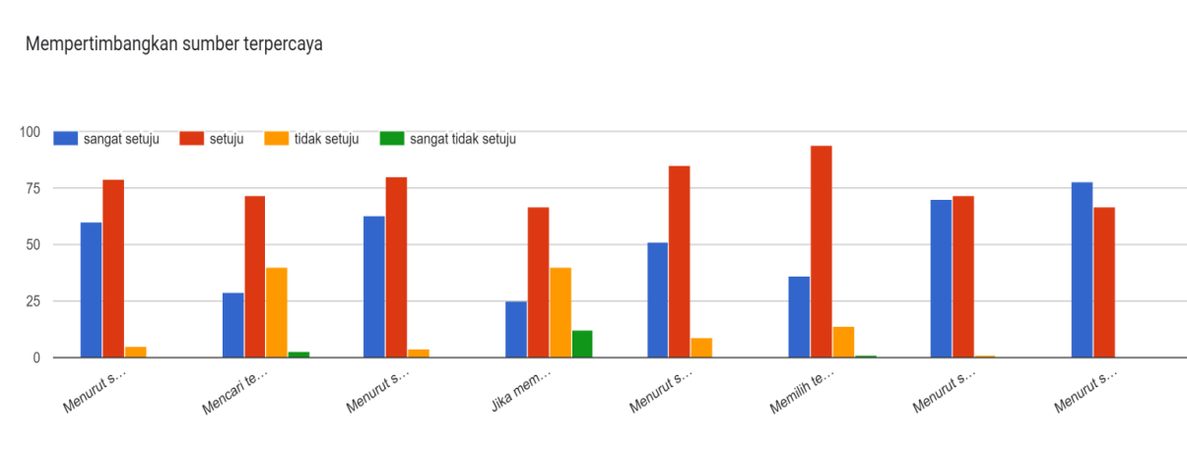
Source ; Researcher
Figure 10. Consider reliable sources
Based on the picture above, it was found that the largest result value was 94% found in the statement items that "the selection of colleagues based on reputation or track record in a team, 85% of students stated "in making programs or making any statements should use procedures that have been recognized as valid, 80 % is found in the statement item that "in making a decision, several sources' opinions must be considered.

- Observation

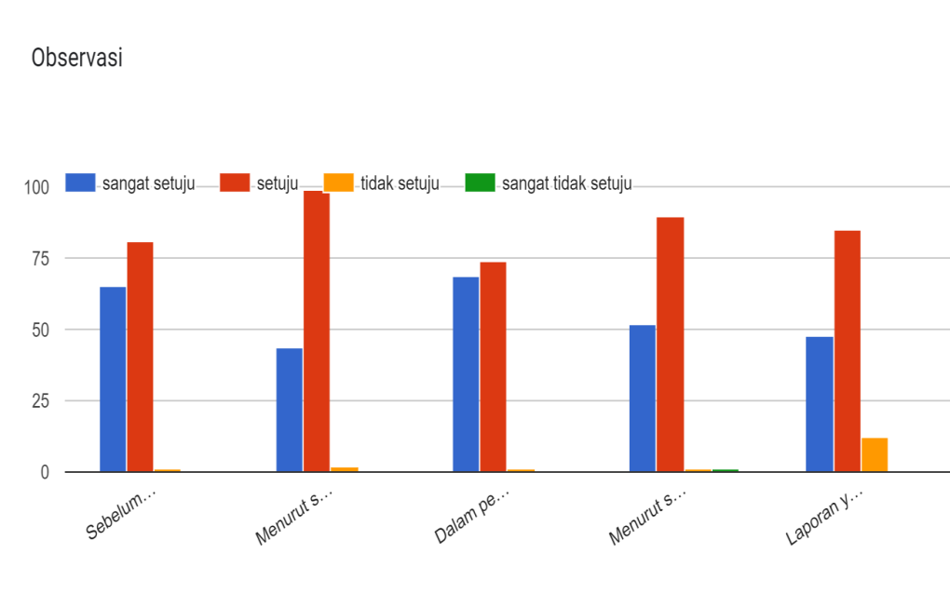
Source ; Researcher
Figure 11. Observation
In the picture above, it was found that the largest value was 99% stating that "the time gap between observation and report generation needs to be considered", and 90% stated the need for technology utilization in reporting.

- Generalize
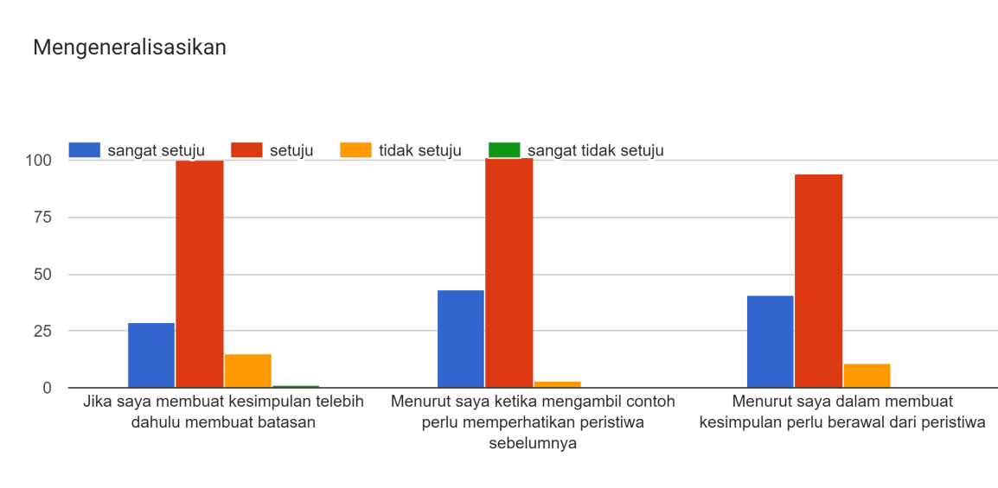
Source ; Researcher
Figure 12. Generalize
In the picture above, it is found that 100% of students stated that there must be a limit in making conclusions, accompanied by statement items stating that in taking samples they should pay attention to previous events. The next value of 94% states that in making conclusions the need for early events.

- Provide an explanation of conclusion

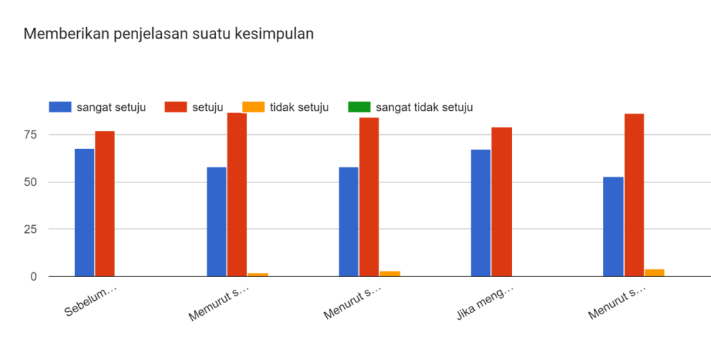
Source ; Researcher
Figure 13. Provide an explanation of conclusion
Based on the picture above, it is found that the largest value is the statement item which states that understanding is needed in providing an explanation according to the source by 87%, in this case students need to strengthen cognitive control as the ability to provide explanations of inaccurate information by analyzing incident by incident to alleviate burden (Sulaeman, Raihan, Siregar, & Sutrisna, 2022) and stated that the need for procedures in decision making is 86%.

- Making and considering decisions
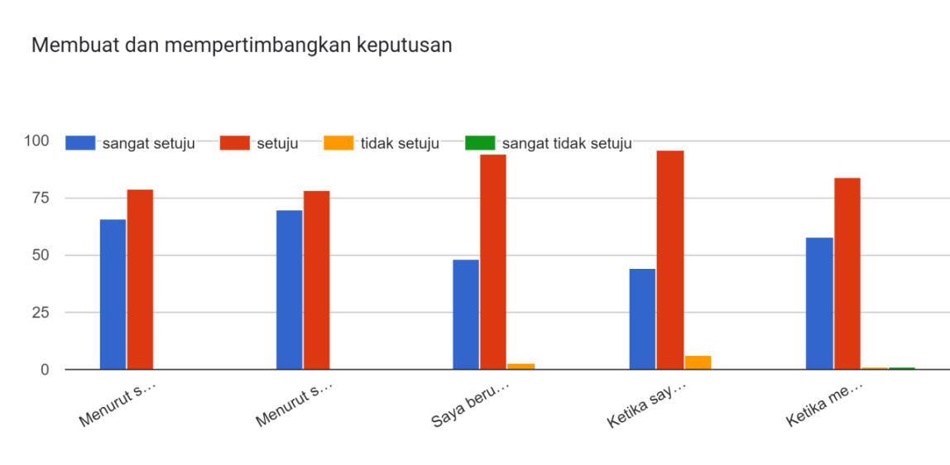
Source ; Researcher
Figure 14. Making and considering decisions

Based on the picture above, it can be said that the largest value is 96% saying it is necessary to take into account several alternatives before making a decision, 94% stated trying to consider the application of the accepted principle.

- Define terms and consider definitions

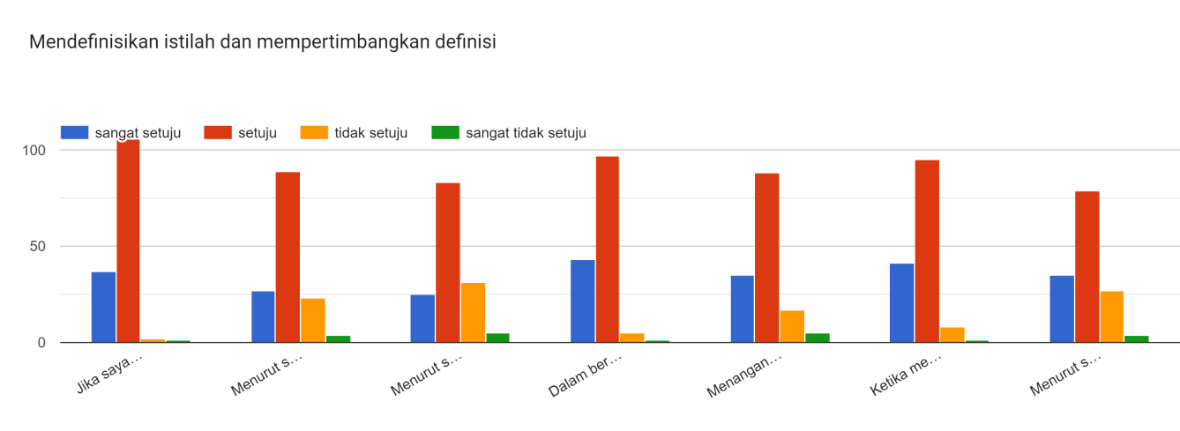
Source ; Researcher
Figure 15. Define terms and consider definitions
Based on the picture above, the largest value is in the statement item that to define the term it is necessary to classify the form first, 97%, 95% stated that the type of response shown can indicate a lie in a conversation.
- Identify assumptions
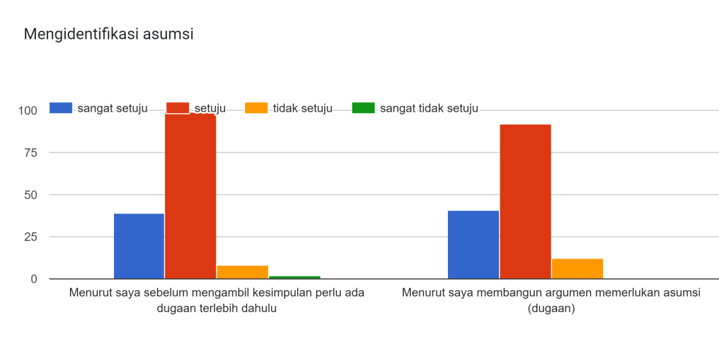
Source ; Researcher
Figure 16. Identify assumptions
Based on the picture above, it was found that the largest results are 99% of the opinion that there is a need for conjecture before making a decision, 92% said that in building an argument, assumptions are needed.
- Define action
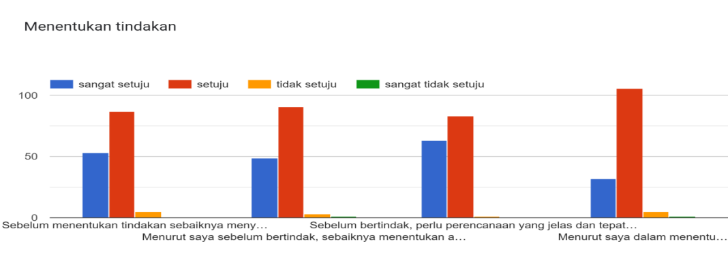
Source ; Researcher
Figure 17. Define action

The picture above shows that the largest value, which is 100%, is found in the habit of formulating alternative solutions, 91% is found in getting used to before taking action, it is better to determine what to do temporarily.
- Interact with other people
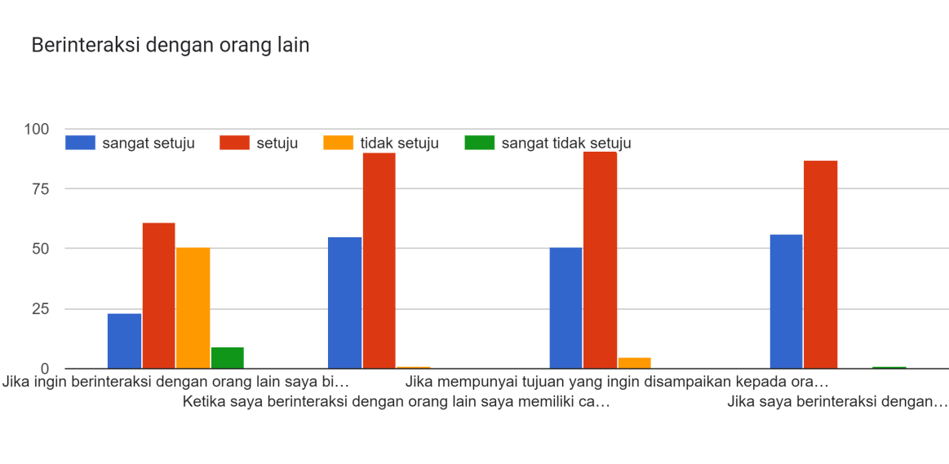
Source ; Researcher
Ficture 18. Interact with other people
Based on the picture above, the largest value is 91% stating that systematic speech and self-confidence are needed in group interaction, and 90% stated that they have their own way of understanding how to interact with others.

CONCLUSION
From the research above, it can be concluded that in the 3 stages that have been carried out several important points in improving the character of students who are critical in the learning process include;
- In focusing the questions, important points were found there are; Focus in formulating problems, as well as formulating question criteria, it is necessary to determine possible answers;
- In analyzing the arguments there are; Identify the reasons to be presented, as well as the relevance of the question to find the structure of an argument;
- In asking and answering clarifying questions, there are; applying character towards an intelligent and rational society becomes a necessity, and is included in every major learning;
- In considering reliable sources are; The selection of "team work" in the task will determine success, accompanied by the validity of the sources used in making a decision;
- In observation there are; the need for a long time in observing a problem until the report becomes an obstacle in the process of equalizing perceptions among members. In addition, less use of technology results in the length of the process;
- In generalizing, the need for literature review becomes an obligation in the conclusion-making process;
- In providing an explanation of a conclusion, there are; understanding is needed in providing explanations according to sources, and procedures in making a decision;
- In making and considering decisions, there are; taking into account several alternatives before making a decision, it is necessary to apply the appropriate principles;
- In defining terms and considering definitions there are; defining terms requires a form classification , so the validity of the response type statement can be known;
- In identifying the assumptions, there are; need some assumptions before making a decision, and assumptions are needed in building the necessary arguments;
- In determining an action, there are; the habit of formulating alternative solutions, and getting used to before taking action, it is better to determine what to do in the meantime;
- In interacting with other people, it takes systematic learning how to speak and confidence in group interactions.

CONFLICT OF INTEREST

There is no conflict among the authors and the sponsors (The Ministry of Education and Culture, Re-search, Technology, and Higher Education of the Republic of Indonesia, Student and Islamic University of Jakarta)

ACKNOWLEDGEMENT

The authors would like to thank the Directorate of Ministry of Education and Culture, Re-search, Technology, and Higher Education of the Republic of Indonesia for its financial. Also, the researchers would like to thank the Islamic University of Jakarta for the assistance of the research.

DAFTAR PUSTAKA

Aulia, S. N., & Dewi, D. A. (2021). Pengaruh Pendidikan Kewarganegaraan Dalam Membangun Karakter Generasi Muda. Jurnal Kewarganegaraan, 5(1). Https://Doi.Org/ 10.31316/Jk.V5i1.1354
Dian Primasari, I. F. N., & Zulela, Z. (2021). Kendala Pembelajaran Jarak Jauh (Pjj) Secara Online Selama Masa Pandemik Covid-19 Di Sekolah Dasar. Jikap Pgsd: Jurnal Ilmiah Ilmu Kependidikan, 5(1). Https://Doi.Org/10.26858/Jkp.V5i1.16820
Efrimal, F., Kurnia, N., & Wasidi. (2017). Penerapan Model Project Based Learning (Pjbl) Untuk Meningkatkan Kecermatan Dan Kreasi Seni Rupa (Studi Pada Siswa Kelas Xi Sma Negeri 3 Seluma). Diadik : Jurnal Ilmiah Teknologi Pendidikan, 7(2).
Fauziah, C., Taufiqulloh, & Sudibyo, H. (2017). Implementasi Model Project Based Learning Pada Pembelajaran Jarak Jauh Berbasis E-Learning Selama Pandemi Covid-19. Pancasakti Science Education Journal, 2(2), 38–48. Https://Doi.Org/10.24905/Psej.V5i2.46
Hayati, W. I., Utaya, S., & Astina, K. (2016). Efektivitas Student Worksheet Berbasis Project Based Learning Dalam Menumbuhkan Kemampuan Berpikir Kritis Siswa Pada Mata Pelajaran Geografi. Jurnal Pendidikan : Teori, Penelitian, Dan Pengembangan, 1(3).
Juliardi, B. (2015). Implementasi Pendidikan Karakter Melalui Pendidikan Kewarganegaraan. Jurnal Bhinneka Tunggal Ika, 2.
Komara, E. (2018). Penguatan Pendidikan Karakter Dan Pembelajaran Abad 21. Sipatahoenan: South-East Asian Journal For Youth, Sports & Health Education, 4(1).
Marlina, Y., & Cahyono, C. (2022). A Conceptualization of Online Collaborative English Learning for Undergraduate Students in the New Normal Post Covid-19 Era. EDUTEC : Journal of Education And Technology, 5(3), 625–639. Retrieved from http://ejournal.ijshs.org/index.php/edu/article/view/317
Melinda, V., & Zainil, M. (2020). Penerapan Model Project Based Learning Untuk Meningkatkan Kemampuan Komunikasi Matematis Siswa Sekolah Dasar (Studi Literatur). Jurnal Pendidikan Tambusai, 4(2).
Naufal, H. A. (2021). Literasi Digital. Perspektif, 1(2). Https://Doi.Org/ 10.53947/ Perspekt.V1i2.32
Pertiwi, A. D., Septian, R. N., Ashifa, R., & Prihantini, P. (2021). Peran Organisasi Kemahasiswaan Dalam Membangun Karakter: Urgensi Organisasi Kemahasiswaan Pada Generasi Digital. Aulad: Journal On Early Childhood, 4(3). Https://Doi.Org/ 10.31004/ Aulad.V4i3.202
Puji Rahmawati, F. (2015). Strengthening Of Character With Students In The Family Engagement Education Muhammadiyah. Jurnal Jpsd (Jurnal Pendidikan Sekolah Dasar), 1(2). Https://Doi.Org/10.26555/Jpsd.V1i2.A2526
Purwadhi, P. (2019). Pembelajaran Inovatif Dalam Pembentukan Karakter Siswa. Mimbar Pendidikan, 4(1). Https://Doi.Org/10.17509/Mimbardik.V4i1.16968
Ramadhani, F. (2020). Penerapan Model Pembelajaran Project Based Learning Untuk Meningkatkan Hasil Belajar Ipa Dalam Pembelajaran Daring Di Kelas Ix Smp. Jurnal Pelita Pendidikan, 8(4).
Ratu, T., Sari, N., Mukti, W. A. H., & Erfan, M. (2021). Efektivitas Project Based Learning Terhadap Efikasi Diri Dan Kemampuan Berpikir Kritis Peserta Didik. Konstan - Jurnal Fisika Dan Pendidikan Fisika, 6(1). Https://Doi.Org/10.20414/Konstan.V6i1.74
Setiono, P., Yuliantini, N., & Dadi, S. (2020). Meningkatkan Nilai Karakter Peserta Didik Melalui Penerapan Model Pembelajaran Project Based Learning. Jurnal Pgsd: Jurnal Ilmiah Pendidikan Guru Sekolah Dasar, 13(1). Https://Doi.Org/10.33369/Pgsd.13.1.85-92
Sugiyono. (2019). Metode Penelitian Pendidikan. Bandung:Alfabeta.
Sulaeman, M., Raihan, Siregar, M., & Sutrisna, A. (2022). Fenomena Perilaku Phubbing Dan Kontrol Diri Pada Remaja Dalam Interaksi Sosial. In Fenomena Phubbing, Kontrol Diri, Sosial Ekonomi Dan Interaksi Sosial (Pp. 1–14). Jakarta: Universitas Islam Jakarta.
Utomo, A. C., Abidin, Z., & Rigiyanti, H. A. (2020). Keefektifan Pembelajaran Project Based Learning Terhadap Sikap Ilmiah Pada Mahasiswa Pgsd. Educational Journal Of Bhayangkara, 1(1). Https://Doi.Org/10.31599/Edukarya.V1i1.103
Wulandari, A. S., Suardana, I. N., & Devi, N. L. P. L. (2019). Pengaruh Model Pembelajaran Berbasis Proyek Terhadap Kreativitas Siswa Smp Pada Pembelajaran Ipa. Jurnal Pendidikan Dan Pembelajaran Sains Indonesia (Jppsi), 2(1). Https://Doi.Org/10.23887/ Jppsi. V2i1.17222

